**Algebra IA** Name _________________________________ Chapter 1 Review Date ___________________ Hour ______

Expressions, Equations, and Functions Review

**Evaluate each expression.**

1. *k* + 9 when *k* = 5 2. –*x* when *x* = 6 3.  when *x* = 21

4. 5*t* when t =  5. *z*3 when *z* = 2 6. *y*2 + 8 when *y* = 10

7. *r*2 – 2 when *r* = 5 8. when m = 15 9. when x = 9

10.  when *x* = 3 11. 2 + 3(*x* + 4) when *x* = 5

12. 3*x*2 + 4(5*x* – 7) when *x* = 2 13. *x*2 + 15 ÷ 3 – 2 when *x* = –7

14. 2[(9 + *y*) ÷ 5] when *y* = 11 15. *x* + *x*3 ÷ 8 when *x* = 2

16. 52 – 7 + 8 17. 67 – 3 ‧ 4 18. 82 ÷ 4 + 12

19. 32 + 2 ‧ 3 ÷ 3 20. 2[33 – (2 + 5)]2 21. 4[(8 + 6) ÷ 7]

22. 2[14 – (2³ - 4)²] 23. –4[1 + (32 - 7)3] 24.

**Translate the verbal phrase into an expression.**

25. The sum of a number *x* and 10 26. This difference of a number *y* and 3

27. The product of the square of a number *p* and 8 28. The quotient of a number *z* and 25

**Write an equation or an inequality.**

29. The product of 12 and a number *r* is 72. 30. The difference of a number *x* and 18 is 10.

31. Six more than twice a number *y* is equal to 20. 32. Ten less than a number *z* is greater than 16.

33. The sum of twice a number *x* and 6 is less than 12.

34. The difference of twice a number *y* and 4 is 12.

35. The product of 5 and a number *n* is at least 21.

36. The quotient of a number *q* and 3 is greater than or equal to 36.

37. The product of 7 and the quantity 3 more than a number x is at most 25

38 The product of 3 and the quantity 2 less than a number y is at least 16

**Choose the more precise measurement.**

39. 5.32cm; 5.2cm 40. 13in; 1.1ft 41. 0.5kg; 450g 42. 1.231cm; 1.2cm

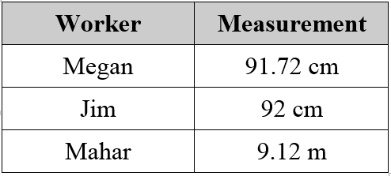43. Three construction workers were asked to measure the width of a door on a site they were building a house that was exactly 91.8 centimeters. Their measurements are shown in the table. Which person made the most precise measurement?

**Determine the number of significant digits in the measurement.**

44. 201 cm 45. 0.0030 sec 46. 40 mm 47. 33.10 in

**Determine whether the pairing is a function.**

48. 49.

|  |  |
| --- | --- |
| **Input** | **Output** |
| 5 | 5 |
| 6 | 10 |
| 7 | 12 |
| 5 | 6 |

|  |  |
| --- | --- |
| **Input** | **Output** |
| 2 | 4 |
| 4 | 8 |
| 6 | 4 |
| 8 | 2 |

**Find the range of the function.**

50. *y* = 5*x* – 2 51. *y* = 0.2*x* + 3

Domain: 1, 2, 3, 4 Domain: 10, 20, 30, 40

Range: Range:

**Write a rule for each function.**

|  |  |  |  |  |
| --- | --- | --- | --- | --- |
| **Input, *x*** | 2 | 4 | 6 | 8 |
| **Output, *y*** | 1 | 2 | 3 | 4 |

52. 53.

|  |  |  |  |  |
| --- | --- | --- | --- | --- |
| **Input, *x*** | 1 | 2 | 3 | 4 |
| **Output, *y*** | 4 | 8 | 12 | 16 |

**Problem Solving.**

54. A car travels at an average speed of 70 miles per hour. How many miles does the car travel in 3 hours?

55. A museum charges $50 for an annual membership and then a price of $2 per ticket. Write an expression to represent the situation. Then find the total cost to join the museum and buy 10 tickets.

56. Robert has $82 in his school lunch account. Each time he buys lunch he spends $3. Write an expression that would represent the value remaining in his lunch account after *x* number of lunches purchased.

57. You pay $5 processing fee to order concert tickets no matter how many tickets you order. Each ticket costs $18. Write an equation that represents *c*, then total cost of ordering *t* tickets.

58. You can convert temperatures in degrees Celsius to degrees Fahrenheit by using the expression

$\frac{9}{5}$ C + 32, where C is the temperature (in degrees Celsius). Convert 20°C to degrees Fahrenheit.

59. A triangle has a height of 25 inches and a base of 12 inches. What is the area of the triangle?

60. A triangle has a height of 11 inches and a base of 18 inches. What is the area of the triangle?

61**. Extended Response**

A flower shop offers the following special for wedding: buy one large bridal bouquet at regular price, and get as many medium bridesmaid bouquets as you would like for $45 each.

a. If the cost of a large bridal bouquet is $150, how much would it cost to purchase one large bridal bouquet and six medium bridesmaid bouquets?

b. Complete the table by calculating the total cost of purchasing one large bridal bouquet and the indicated number of medium bridesmaid bouquets.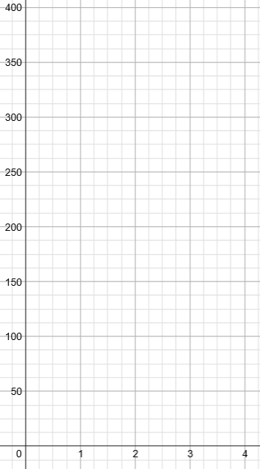 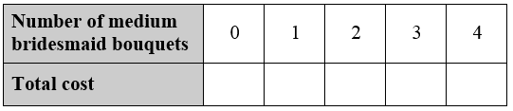

c. Graph the function for total cost using your work in the table above.

d. Write a rule for the function representing the total cost of purchasing one large bridal bouquet and *m* medium bridesmaid bouquets.

e. Your budget for the wedding bouquets is $500. How many medium bridesmaid bouquets could you purchase assuming that you also purchase the bridal bouquet?